To update from WSL1 to WSL2

1. Turn Virtual Machine feature on (See below: Control Panel -> Programs -> Turn Windows features on or off, check the Virtual Machine Platform feature, click OK.)

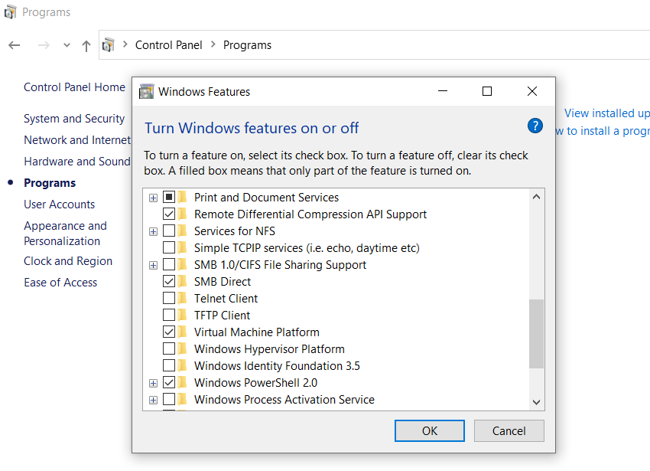

1. Restart computer to apply the change.
2. Download the installer for the WSL2 kernel from the site below and run it.

<https://docs.microsoft.com/en-us/windows/wsl/wsl2-kernel>

1. Run the following command in PowerShell or command prompt to list the Linux distribution and the WSL version that it is running on:

wsl –-list –verbose



1. To upgrade your current distribution from WSL1 to WSL2, run the following command in PowerShell or command prompt (substitute **Ubuntu** by the distro name from your list, State may be running or stopped.):

wsl –-set-version **Ubuntu** 2

1. 
2. Enter the list command again, you will see
3. The Ubuntu you launch now from the Start menu will run on WSL2.